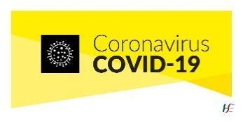
COVID-19 Return to School Form

Name of School: North Monastery Primary School
Child’s Name: | Class Teacher:
Classroom: | Return Date:
 |  | Yes | No
Has your child attended the GP?
Was the Covid19 test positive?
Has any other close family member been diagnosed with Covid19?
Does your child still have a temperature?
Does your child have any further symptoms of Covid19?
Is your child fully recovered now?
Did your GP give permission for your child to return to school?
Do you have a letter from the GP?
Any other comments?

Parent’s/Guardian’s name:____________________________ Date: ________

Parent’s/Guardian’s signature: _________________________

